/*Declare a class called MOVIE with the following members:

Data Members:

* Name of the movie
* Name of the director
* Name of the producer
* Grading

Member Functions:

* To initialize the data members
* To display the movie details

Write a program to create an array of 5 objects. */

#include<iostream.h>

#include<stdio.h>

class MOVIE

{

char mname[25],dir[25],pro[25]gra[1];

public:

void input_data()

{

cout<<"Enter MOVIE name : ";

gets(mname);

cout<<"\nEnter MOVIE director: ";

gets(dir);

cout<<"\nEnter MOVIE producer: ";

gets(pro);

cout<<"\nEnter MOVIE Grading : ";

gets(gra);

}

void display()

{

cout<<"\nMOVIE name is: "<<mname;

cout<<"\nMOVIE director is: "<<dir;

cout<<"\nMOVIE producer is: "<<pro;

cout<<"\nMOVIE Grading is: ";

puts(gra);

}

};

void main()

{

for (int i=0;i<5;i++)

{

MOVIE E;

E.input_data();

E.display();

cout<<"\n";

}

}

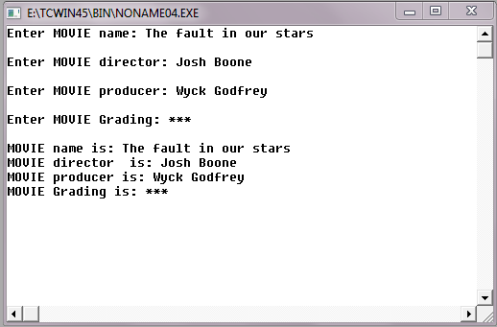**OUTPUT**

